Front End Technologies Week 1 Coding Assignment

**Points possible:** 70

|  |  |  |
| --- | --- | --- |
| Category | Criteria | % of Grade |
| Functionality | Does the code work? | 25 |
| Organization | Is the code clean and organized? Proper use of white space, syntax, and consistency are utilized. Names and comments are concise and clear. | 25 |
| Creativity | Student solved the problems presented in the assignment using creativity and out of the box thinking. | 25 |
| Completeness | All requirements of the assignment are complete. | 25 |

**Instructions:** In VS Code, or an IDE of your choice, write the code that accomplishes the objectives listed below. Ensure that the code compiles and runs as directed. Take screenshots of the code and of the running program (make sure to get screenshots of all required functionality) and paste them in this document where instructed below. Create a new repository on GitHub for this week’s assignments and push this document, with your JavaScript project code, to the repository. Add the URL for this week’s repository to this document where instructed and submit this document to your instructor when complete.

**Coding Steps:**

1. Create a website using only HTML. The website can be anything you like (within school guidelines) as long as it meets the following criteria – website must contain:
   1. At least 3 pages
   2. Links to navigate between all pages present on each page
   3. A list
   4. 3 images
   5. 2 different size headers
   6. A table
   7. A form

**Screenshots of Code:**

<!-- index.html -->

<!--

By Tim Gibney

20210116

-->

<!--

1.  Create a website using only HTML. The website can be anything you like

(within school guidelines) as long as it meets the following criteria – website must contain:

    a.  At least 3 pages

    b.  Links to navigate between all pages present on each page

    c.  A list

    d.  3 images

    e.  2 different size headers

    f.  A table

    g.  A form

-->

<!DOCTYPE html>

<html lang="en">

<head>

    <meta charset="UTF-8">

    <meta name="viewport" content="width=device-width, initial-scale=1.0">

    <title>FESD FET Week 1 - Index</title></head>

<body>

    <h1>Index</h1>

    <h3>Links in a &ltdiv&gt</h3>

    <div>

        <a href="index.html">Index </a>

        <a href="page1.html">Page 1</a>

        <a href="page2.html">Page 2</a>

    </div>

    <!--<h3 align="center">Links in a nav</h3>  <!--align="center" is deprecated but apparently still works-->

    <h3>Links in a &ltnav&gt</nav></h3>

    <nav>

        <ul>

            <li><a href="index.html">Index </a></li>

            <li><a href="page1.html">Page 1</a></li>

            <li><a href="page2.html">Page 2</a></li>

        </ul>

    </nav>

    <nav>

        <a href="index.html">Index </a>

        <a href="page1.html">Page 1</a>

        <a href="page2.html">Page 2</a>

    </nav>

    <h3>Links in a table with headers and rows</h3>

    <!--<table border="10" cellspacing="10" cellpadding="20" style="width:25%" align="center">-->

    <table>

        <tr>

            <th>Web Page</th>

            <th>URL</th>

        </tr>

        <tr>

            <td align="center"><a href="index.html">Index </a></td>

            <td align="center">index.html</td>

        </tr>

        <tr>

            <td><a href="page1.html">Page 1</a></td>

            <td>page1.html</td>

        </tr>

        <tr>

            <td><a href="page2.html">Page 2</a></td>

            <td>page2.html</td>

        </tr>

    </table>

    <h3>An Ordered List</h3>

    <ol><!--Ordered list creates a list with leading numbers-->

        <li>HTML</li><!--List items-->

        <li>CSS</li>

        <li>JavaScript</li>

    </ol>

    <h3>A Horizontal Rule</h3>

    <hr/><!--Horizontal rule-->

    <h3>The beginnings of a form</h3>

    <form>

        <input type="text" name="firstName" placeHolder="First Name"><br>

        <input type="text" name="lastName" placeHolder="Last Name"><br><br>

        Beautiful Nature:<br>

        <input type="radio" name="which image" value="CrocEyes"> Croc Eyes <br>

        <input type="radio" name="which image" value="Gecco"> Penguins <br>

        <input type="radio" name="which image" value="Penguins"> Gecco <br>

        <input type="submit" value="Submit">

    </form>

    <hr>

    <a href="index.html">

    <img src="3000.jpg" height="200" alt="Croc eyes">

    </a>

    <a href="page1.html">

    <img src="3001.jpg" height="200" alt="Gecco">

    </a>

    <a href="page2.html">

    <img src="3002.jpg" height="200" alt="Penguins">

    </a>

    <h3>Some buttons with links</h3>

    <button onclick="location.href='index.html'" type="button">Index</button>

    <button onclick="location.href='page1.html'" type="button">Page 1</button>

    <button onclick="location.href='page2.html'" type="button">Page 2</button>

</body>

</html>

<!-- page1.html -->

<!--

By Tim Gibney

20210116

-->

<!DOCTYPE html>

<html lang="en">

<head>

    <meta charset="UTF-8">

    <meta name="viewport" content="width=device-width, initial-scale=1.0">

    <title>FESD FET Week 1 - Page 1</title></head>

<body>

    <h1>Page 1</h1>

    <h3>Links in a &ltdiv&gt</h3>

    <div>

        <a href="index.html">Index </a>

        <a href="page1.html">Page 1</a>

        <a href="page2.html">Page 2</a>

    </div>

    <table>

        <tr>

            <td><a href="index.html">Index </a></td>

            <td><a href="page1.html">Page 1</a></td>

            <td><a href="page2.html">Page 2</a></td>

        </tr>

    </table>

    <ol>

        <li>HTML</li>

        <li>CSS</li>

        <li>JavaScript</li>

    </ol>

    <hr>

    <a href="index.html">

    <img src="3000.jpg" height="200" alt="Croc eyes">

    </a>

    <a href="page1.html">

    <img src="3001.jpg" height="200" alt="Gecco">

    </a>

    <a href="page2.html">

    <img src="3002.jpg" height="200" alt="Penguins">

    </a>

</body>

</html>

<!-- page2.html -->

<!--

By Tim Gibney

20210116

-->

<!DOCTYPE html>

<html lang="en">

<head>

    <meta charset="UTF-8">

    <meta name="viewport" content="width=device-width, initial-scale=1.0">

    <title>FESD FET Week 1 - Page 2</title></head>

<body>

    <h1>Page 2</h1>

    <h3>Links in a &ltdiv&gt</h3>

    <div>

        <a href="index.html">Index </a>

        <a href="page1.html">Page 1</a>

        <a href="page2.html">Page 2</a>

    </div>

    <table>

        <tr>

            <td><a href="index.html">Index </a></td>

            <td><a href="page1.html">Page 1</a></td>

            <td><a href="page2.html">Page 2</a></td>

        </tr>

    </table>

    <ol>

        <li>HTML</li>

        <li>CSS</li>

        <li>JavaScript</li>

    </ol>

    <hr>

    <a href="index.html">

    <img src="3000.jpg" height="200" alt="Croc eyes">

    </a>

    <a href="page1.html">

    <img src="3001.jpg" height="200" alt="Gecco">

    </a>

    <a href="page2.html">

    <img src="3002.jpg" height="200" alt="Penguins">

    </a>

</body>

</html>

**Screenshots of Running Application:**

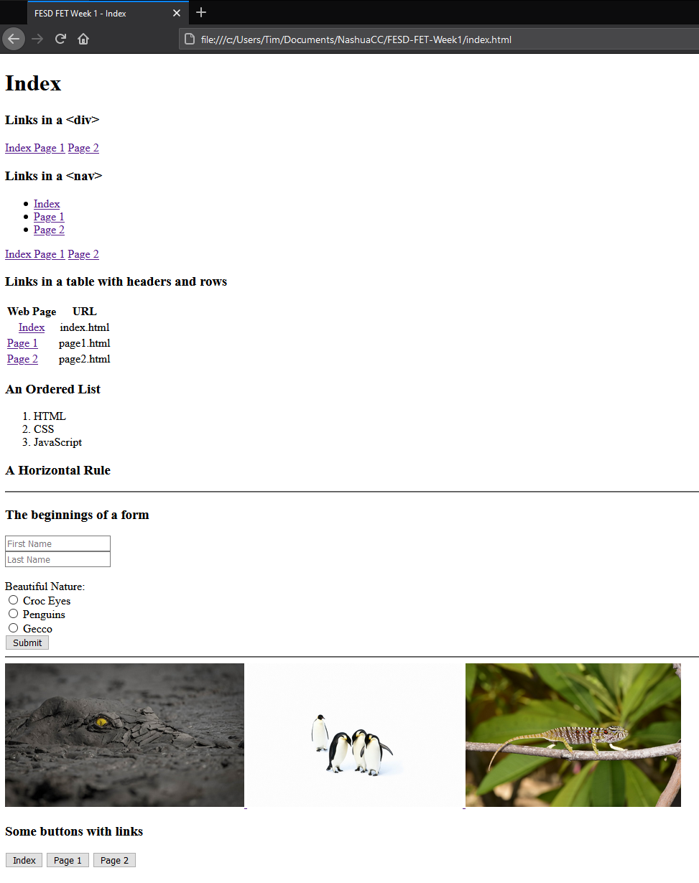

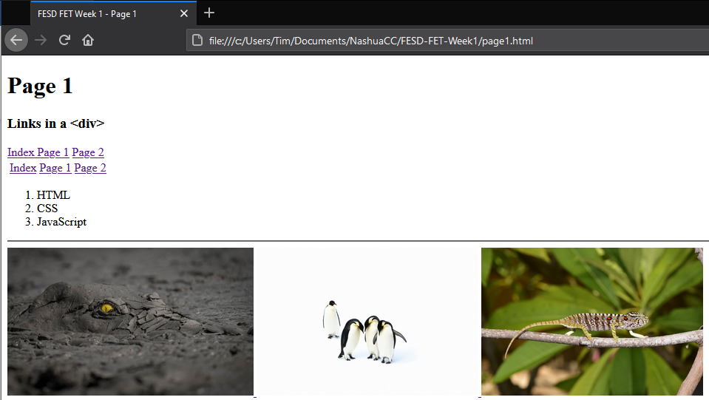

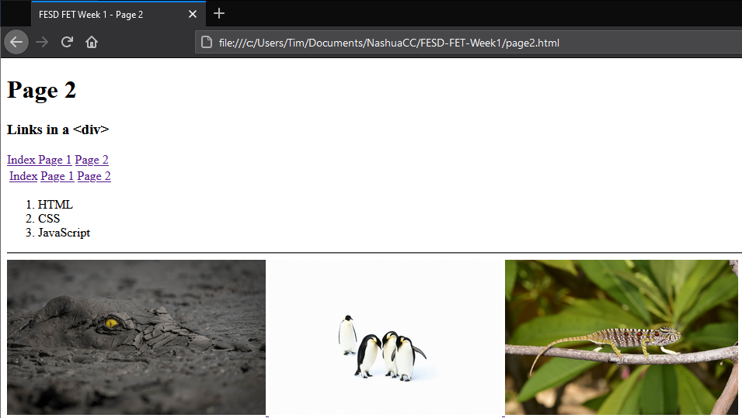

**URL to GitHub Repository:**